Wells that have the gas purchasers Targa, WTG, ETC, Enlink, and Brazos will now have new accounting rules effective dated for July production.

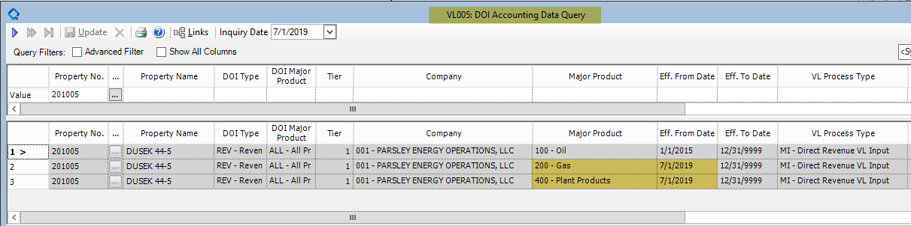

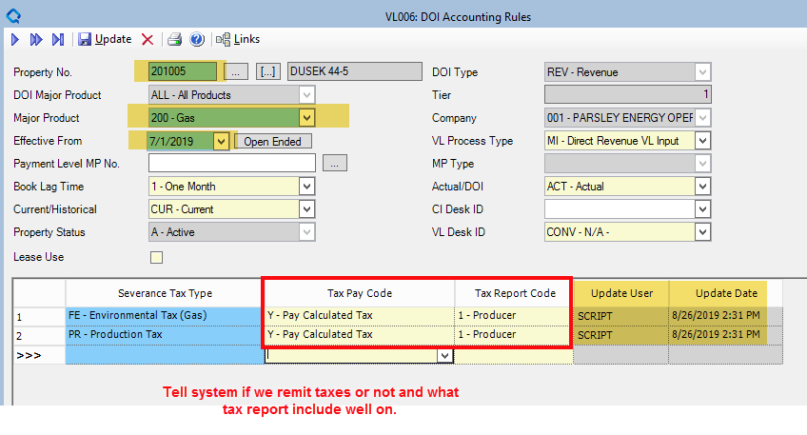

Old rules will be end-dated as PPAs will still follow the old setup.

